There are 3 ways to run and test

1. Using Intellij Idea
2. Using the docker image
3. Using the Jenkins pipeline
4. Make sure port 3000 available for tomcat server
5. Added various test scenarios
6. From the browser url, change city name and verify input and output
7. When a valid city is given : “localhost:3000/noida”
8. Verify the output

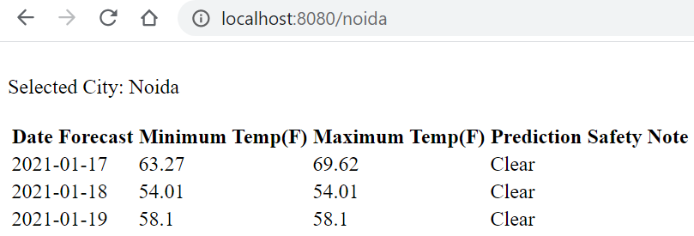

1. When a valid city is given : “localhost:8080/london”
2. Verify the output

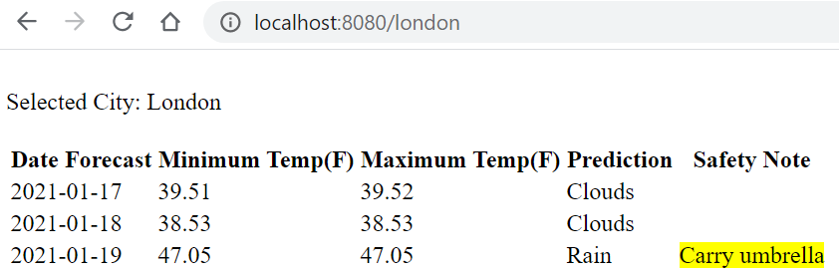

1. When an invalid city name is given : “abc”
2. Verify output

